Entertainer Analysis

Wireframe Documentation

In accordance to the problem statement, the project has been divided in the chunks of visualizations for making the analysis more feasible.

**1. Age by Birth Year and Gender**

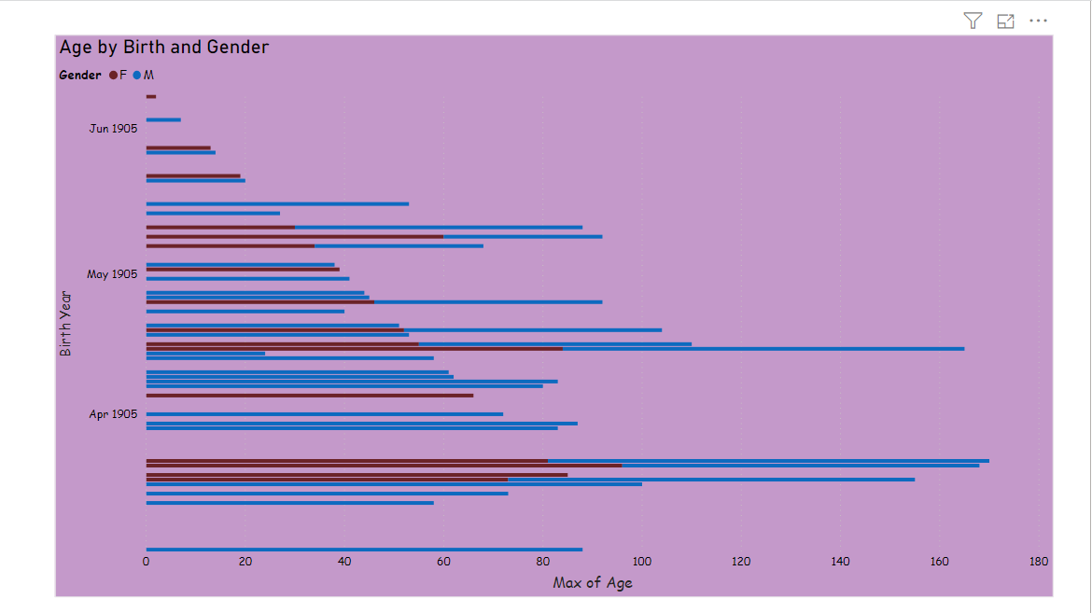

In the next visual , it displays the age by death year with gender.

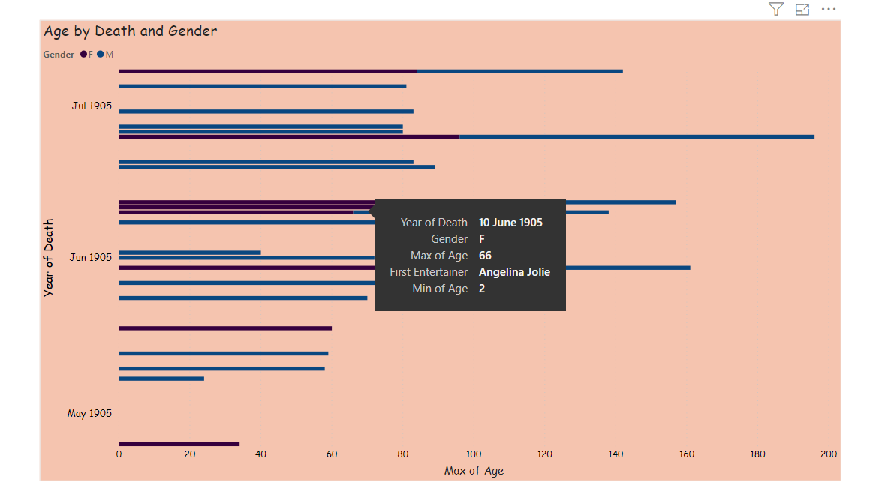

**2. Age By year of Oscar and Gender**

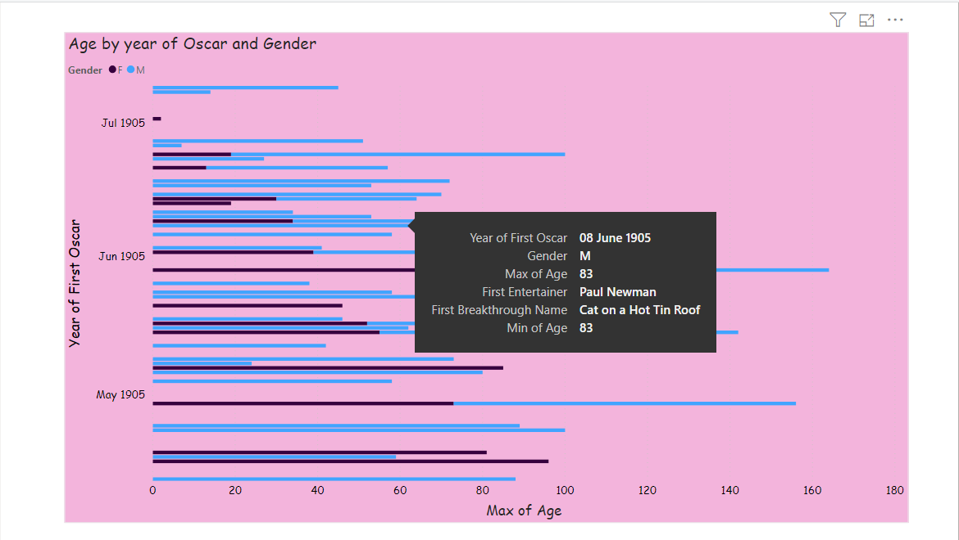

**3. Age by Last Work Year and Gender**

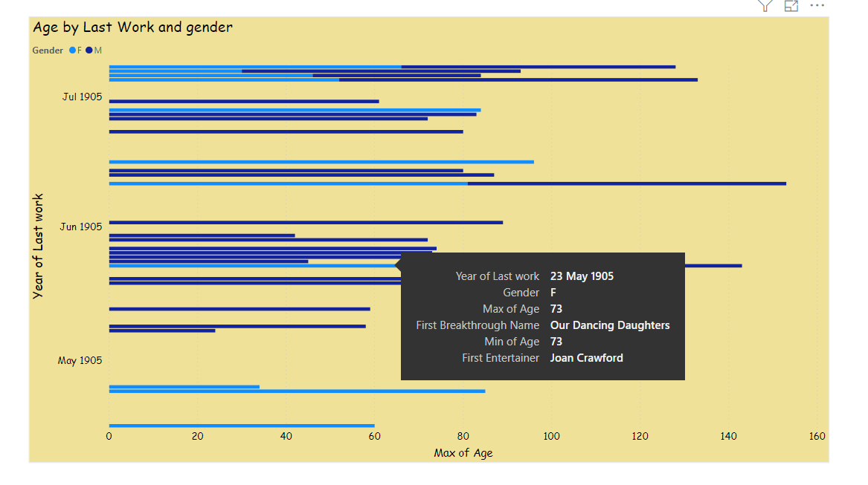

This , came to the dashboard of the analysis of the entertainers.

The dashboard focuses on the Entertainers with their birth year , death year , age and Gender.

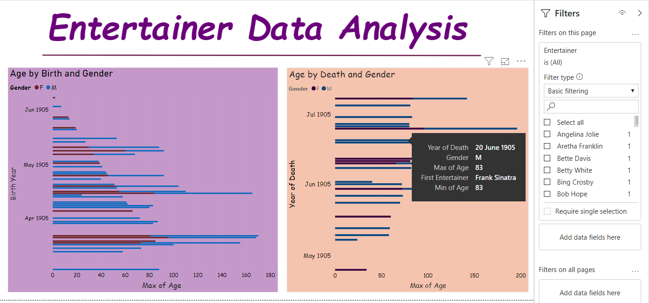

The next dashboard focuses on the Entertainers with the year of Oscar , year of last work , age , Gender and Breakthrough names.

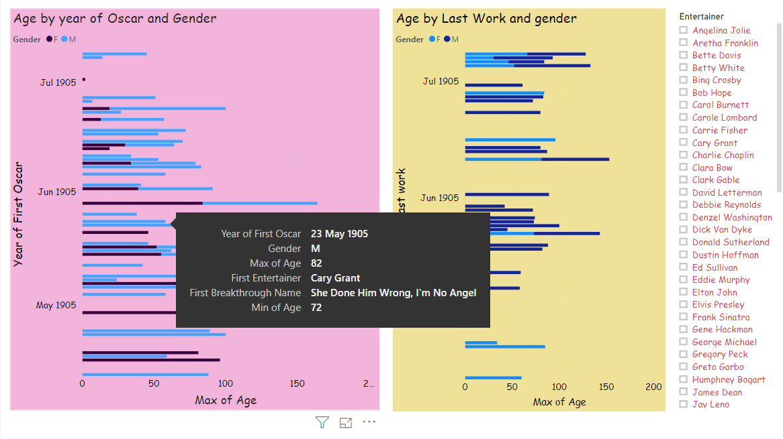

**Deriving Relationships between the variables**

The relationship between birth year and year of death in accordance with gender.

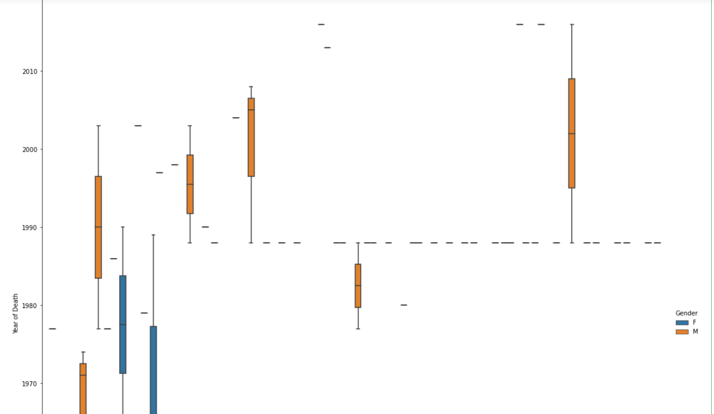

The relationship between gender and entertainer

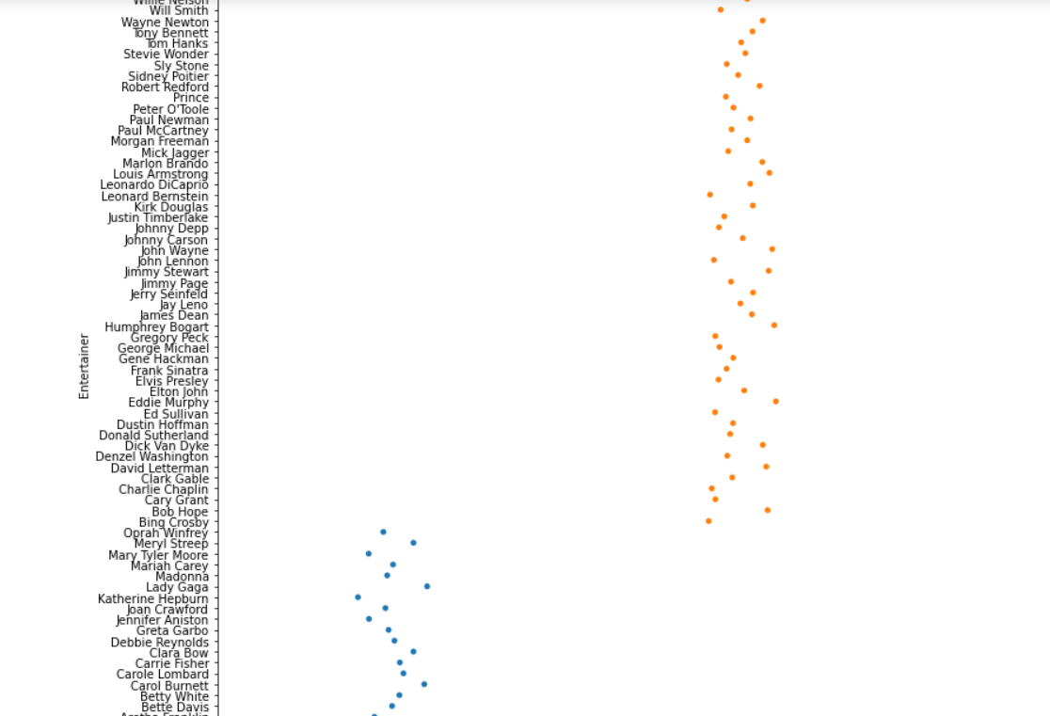

The relationship between the birth year and year of death with the gender and breakthrough name

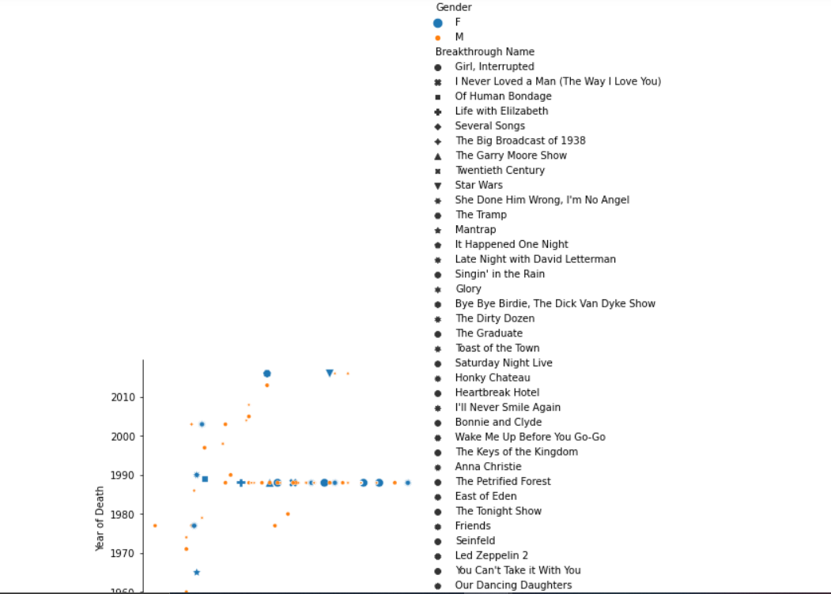

The relationship between birth year and year of death with entertainer

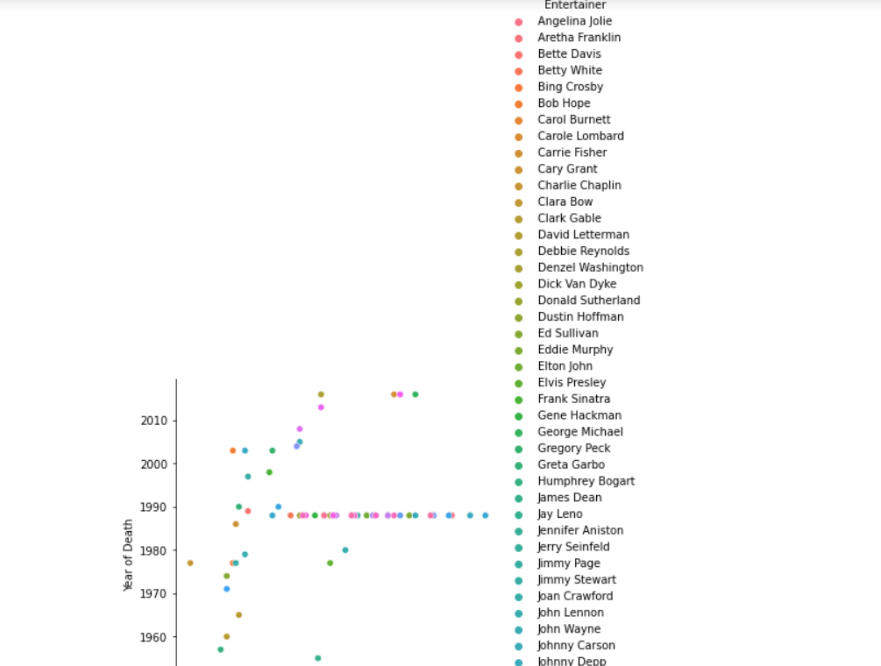

The relationship between birth year and year of death with gender

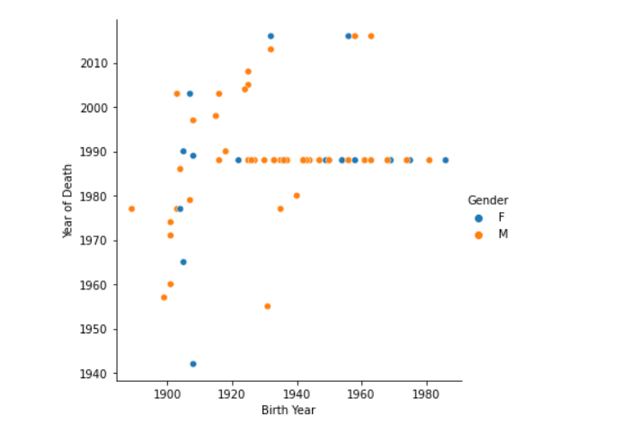

Bar plot of gender

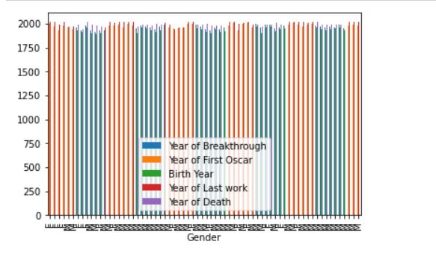

The relationship between entertainer, birth year and death year with breakthrough name.

